FORUM: ECONOMIC AND SOCIAL COUNCIL
QUESTION OF: FINDING WAYS FOR THE INTERNATIONAL ORGANISATIONS TO EFFECTIVELY ENFORCE AND PROMOTE FAIR LABOUR PRACTICES AND EQUITABLE WAGES ACROSS DIFFERENT COUNTRIES
PRESIDENT: NICOLAS KÄTZNER
VICE PRESIDENT: POLINA FISUNOVA
PRESIDENT EMAIL: NICOLAS.KAETZNER@GYM-MEIENDORF.DE
VICE PRESIDENT EMAIL: POLUNA1002@GMAIL.COM

- Description of the Issue
The ideal of economic justice is underpinned by fair labor practices and salaries. The two represent the social and economic norms that are necessary requirements for balanced growth. In as much as global labor rights have been advocated for all over the world and international standards have been drafted, deplorable conditions and exploitation remain a present issue for workers all around the world and a detrimental factor for the dignity and economic well-being of millions of people. The problem is quite complex, with deep-seated reasons such as uneven development of economies, lack of effective global institutions, and the adverse effects of globalization. Access to fair labor practices links with a multitude of rights: The right to a clean working environment, the right to join a union, the right to nondiscrimination, the right to a standard workweek, the right to be protected from using child- or forced labor, etc. Access to fair remuneration, which plays an important role in these practices, means being paid for what one has practiced without discrimination due to gender, ethnicity, age, or other factors, intending that everyone should be able to earn a decent subsistence standard that covers the costs of a decent standard of living. However, these parameters do not seem to be universal.
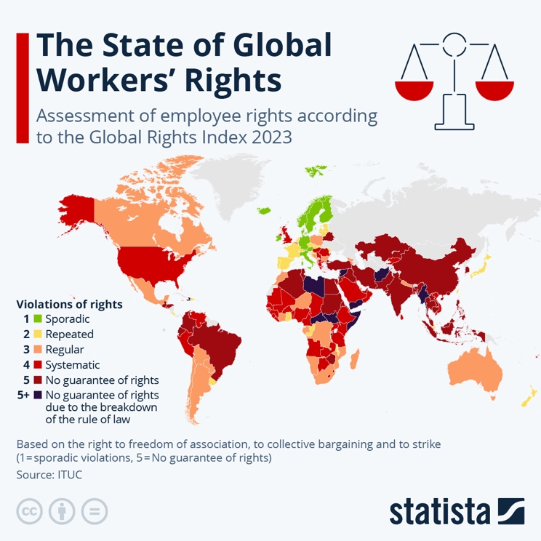
Figure 1: The State of Global Worker’s Rights:
https://cdn.statcdn.com/Infographic/images/normal/29844.jpeg

One of the main drivers of unfair labor conditions is rapid globalization, without which many of the current conditions would likely not have existed. Many examples of the past have shown that global trade and investment, with little regulation, tend to create stages of economic growth in both local and global economies. What is often neglected, however, are the negative effects on the entire spectrum. Variously, there appears to be illegitimate competition at the expense of poor laborers when companies trim costs in attempts to shift the ground of production to the areas where labor laws are weak.
Poor working conditions and underemployment, coupled with unequal payment structures, have been issues mostly in garment-making, agriculture, and electronics, but also in other industries. Such practices are mostly felt by vulnerable groups: women, migrants, or those in the informal sector. The injustice is additionally embodied by gender disparities in the labor market. According to the International Labour Organization (ILO), women earn, on average, approximately 20% less than their male counterparts, with common reasons ranging from differences in educational attainment to wage penalties from motherhood.
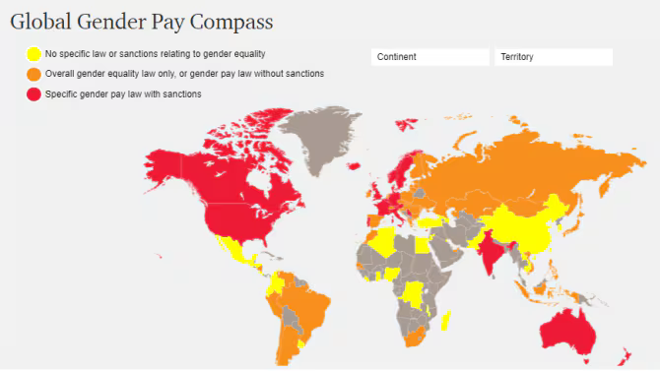
Figure 2: Global Gender Pay Compass:
https://www.pwc.com/gx/en/about-pwc/assets/gender-pay-compass-image.png

Additional forms of discrimination worsen the gap even further. At the same time, migrant workers contributing to construction and domestic services notably feel the brunt of such incidents due to the unavailability of legal passage. Sixty percent of the workforce, whom the ILO refers to as informal workers, are also one of the affected groups. Most of the time, they do not possess legal contracts and are, therefore, not entitled to minimum wage and social security systems, thus making them more vulnerable.
Another more complex layer is insufficient enforcement mechanisms coupled with the absence of clear law provisions. Even though ILO conventions speak about certain minimum acceptable levels in labor practices, its implementation largely shifts to the individual nations that have different levels of enforcement capacity. In some cases, political concerns and inadequacy of resources make upholding laws impossible. Furthermore, corruption and lack of supervision pose challenges even to states with strong laws. In relation to this, when classifying economic policies that emphasize how a national economy can be competitive within the world market, oftentimes, employment aspects are even left out.
Organizations like Fair Labor Association (FLA) have created voluntary codes that various companies in global supply chains can use to demonstrate corporate social responsibility. However, there are expectations that such initiatives would be enforceable. Reports from the early 21st century examining big industries specified cases in which such codes were ignored or poorly executed, further diminishing faith in self-regulation. Another approach to help resolve the wage disparity problem was how wage equality can be defined and its observance made possible. For instance, the norm in China for wages is different from the one in France, Italy, or the US. A key issue, however, was how this goal could be achieved. This tension becomes even sharper in countries where the economies are rapidly advancing, and gig work, as well as platform work, is on the rise. Contemporary phenomena undermine traditional employer-employee relations, which hinder minimum wage compliance and several other labor rights.
Such problems have far-reaching implications that extend beyond those who are affected. Labor exploitation in a systemic manner weakens the economy, creates social problems, and perpetuates poverty. In what they respectively trade, these forms of businesses will be operating under reputational risk as well as supply chain disruptions, which will hurt the trust of the customers. Because there is less payment, workers have less purchasing power, and economic growth prospects are poor.

- Definition of Key Terms
- Fair Labor Practices:
Employment conditions adhering to international labor standards, including safety, rights to organize, non-discrimination, and protection from exploitation

- Equitable Wages:
Compensation that reflects the work performed, without discrimination based on gender, ethnicity, or other factors, ensuring a livable income

- Global Supply Chains:
Networks involved in the production and distribution of goods, often spanning multiple countries with varying labor laws

- Living Wage:
A minimum income required to live an average lifestyle with basic necessities such as food, housing, healthcare, transportation, and clothing. This can vary by country and region and is therefore contrary to a standard minimum wage

- Labor Exploitation:
Practices involving underpayment, excessive working hours, unsafe conditions, or forced labor

- Informal Employment:
Jobs that are not under the regulation of national labor laws, often without written contracts or legal agreements. They are often underpaid and lack occupational safety and governmental support such as social security or health insurance

- Globalization:
The increasing global interdependence and interconnectedness in various sectors

- Gig Work:
Individuals engaged in temporary, flexible, or freelance work arrangements, often on a task-by-task basis rather than being permanently employed They are typically paid per job and lack traditional employment benefits, such as health insurance or retirement plans

- Platform Work:
Individuals who provide goods or services mediated by digital platforms, such as ride-sharing or food delivery apps. These platforms act as intermediaries connecting workers to consumers, but their employment status is often ambiguous, leading to challenges in securing rights and protections

- Background Information
The origins of unfair labor practices can be traced back to the Industrial Revolution when factory owners made use of the dependency of their workers for their financial gains. Movements towards reforms quickly formed due to the usage of children as laborers, long working shifts and poor working environments. The late 19th and early 20th centuries were pivotal in terms of the beginning of worker organizations and labor legislation in developed countries. On the other hand, the globalization of markets, which began in the latter part of the 20th century, changed this scenario remarkably. Globalization not only created opportunities for economic growth in developing countries but also allowed workers to be exploited by enabling companies to shift production to places with lower costs of doing business. Competitive pressures led to major salary declines, eroded employment prospects, and weakened bargaining rights of workers. Global supply chains in the clothing and electronics industry are a prime example of these difficulties. For instance, the collapse of the Rana Plaza building in Bangladesh in 2013 illustrated the deadly underside of the cost-cutting drive and the disregard for worker safety, which left more than 1,100 people dead.
Thus, the deprivation of labor is an expression of economic inequality itself. Many developing countries are unable to enforce such laws or are unable to do so because of the absence of means and institutional structure. The majority of the workers from these countries work in the informal economy, which is unregulated and does not have coverage from the national legal system.
Additionally, one of the most pressing present issues is that there has not been much movement in closing wage gaps. There also doesn't seem to be any reason for many employment sectors to make changes, as they are often largely characterized by wage fluctuations, employment insecurity, and child wages. The 2023 World Economic Forum Global Gender Gap Report estimates that it will take at least 200 years to close the gender pay gap. Racial and other minorities face even more discrimination than the general population, and when it comes to agricultural migrant workers, this discrimination reaches astounding heights. Many of them work for much less than the base minimum wage, with inferior conditions and environments built for exploitation. However, the problems did not go unnoticed and several international bodies attempted to tackle the issues at hand. The International Labour Organization or ILO which was established in 1919, has the authority to set the basic standards and conventions in relation to labor. ILO and UN Global Compact (UNGC) are organizations under the United Nations that have Initiatives that focus on decent work in compliance with the UN’s Sustainable Development Goal (SDG) 8. The ILO considers closing gaps between member states a top priority.
Still, many international instruments and treaties remain unimplemented. This includes the signing of ILO conventions, which many member countries do, and the ending lack of proper tools and systems for monitoring and reporting breaches of such ILO conventions due to a lack of funding. Furthermore, the rise of online platform work also increases the potential risks for unprotected workers who are already vulnerable to exploitive labor conditions.

- Major Countries and Organisations Involved
- International Labour Organization (ILO):
Specialized agency of the United Nations that promotes fair working conditions and plays a key role in defining global labor standards and monitoring compliance with them

- Fair Labor Association (FLA):
Offers support to workers affected by unfair labor conditions as well as accreditation programs for companies willing to improve working conditions in their supply chains

- United Nations Development Programme (UNDP):
Promotes decent work as part of its commitment to achieving Sustainable Development Goal 8. It collaborates with member states to develop policies aimed at inclusive economic growth, poverty eradication, and improved labor conditions. UNDP’s role extends to financing development programs that empower workers, supporting micro and small enterprises, and strengthening social protection mechanisms for marginalized populations

- UN Global Compact (UNGC):
Engages with businesses worldwide to align their operations with universal principles on human rights, labor, environment, and anti-corruption. Through its labor principles, it encourages corporations to adopt policies ensuring fair wages, safe workplaces, and freedom of association. UNGC initiatives like the "Decent Work" platform provide tools, best practices, and metrics for businesses to improve labor conditions globally

- European Union (EU):
Is a key partner of ILO advocating for humane labor practices globally

- G20 Nations:
Significantly influence labor market policies and trade standards. Through initiatives like the G20 Employment Working Group, these nations discuss best practices, promote youth employment, and develop guidelines for fair globalization that prioritize job creation and workers' rights in global supply chains

- China and India:
Large economies with significant contributions to global manufacturing, often scrutinized for labor practices

- Bangladesh, Vietnam, and Ethiopia:
Key exporters of manufactured goods with challenges related to low wages and unsafe working environments

- Previous Attempts to Solve the Issue
- ILO Conventions and Recommendations:
The ILO has been at the forefront of global efforts, establishing key conventions such as the Forced Labour Convention (1930) and the Equal Remuneration Convention (1951). These instruments aim to promote decent work and protect against exploitation. While these conventions have been ratified by many nations, their enforcement remains inconsistent due to political and resource constraints. Additionally, the ILO monitors member countries through periodic reporting and offers technical assistance to strengthen institutional capacities

- Corporate Social Responsibility (CSR) Initiatives:
Multinational corporations have adopted voluntary codes of conduct and joined initiatives like the United Nations Global Compact to demonstrate adherence to ethical labor practices. These measures often involve independent audits and certifications to ensure compliance with international labor standards. However, the voluntary nature of these initiatives limits their effectiveness, as noncompliance rarely results in significant consequences

- Global Framework Agreements (GFAs):
GFAs between multinational corporations and global unions have provided platforms for negotiating labor protections across supply chains. These agreements emphasize mutual commitments to uphold fair labor practices in all countries where the corporations operate. Despite these successes, GFAs are not universally adopted, and their impact remains confined to participating companies

- Sustainable Development Goals (SDGs):
SDG 8 explicitly aims to "promote sustained, inclusive, and sustainable economic growth, full and productive employment, and decent work for all." Various programs under the SDG framework target labor equity through international partnerships and funding for capacity-building initiatives

- Regional and Bilateral Trade Agreements:
Some agreements incorporate labor standards as binding commitments. For instance, the United States-Mexico-Canada Agreement (USMCA) includes provisions on freedom of association and collective bargaining. However, enforcement mechanisms for such provisions vary widely, depending on the participating states’ political will

- Possible Solutions

- Harmonizing Global Labor Standards:
Establishing a unified international framework that sets minimum labor standards for wages, working hours, and safety across countries. This framework would account for national differences while providing universally enforceable minimums, ensuring a consistent baseline for protection

- Strengthening Enforcement Mechanisms:
Empowering international organizations like the ILO with greater enforcement authority, including the ability to impose sanctions or penalties on member states and corporations that violate labor standards. Supporting this, creating independent oversight bodies to monitor compliance would ensure greater accountability

- Enhancing Supply Chain Transparency:
Mandating transparency in global supply chains by requiring corporations to publicly disclose suppliers and labor practices. Technologies like blockchain can be utilized to create traceable records of workplace conditions and wages, ensuring greater consumer awareness and corporate accountability

- Incentivizing Compliance through Trade:
Integrating labor standards into international trade agreements as enforceable obligations, providing positive incentives, such as tariff reductions or trade preferences, for countries and companies demonstrating adherence to ethical labor practices

- Expanding Technology-Driven Solutions:
Developing digital tools and platforms to facilitate worker complaints and identify systemic violations. Smartphone apps allowing workers to anonymously report unsafe conditions or wage theft could significantly empower labor forces in remote and vulnerable communities

- Building Institutional Capacities:
Providing technical and financial support to developing countries to enhance their labor inspection services and judicial frameworks. Capacity-building efforts would ensure local institutions have the resources to enforce labor laws effectively

- Fostering Multistakeholder Collaborations:
Establishing collaborative platforms involving governments, corporations, unions, and civil society to develop and implement fair labor practices. Public-private partnerships can co-create innovative solutions tailored to specific industries and regions

- Educating and Empowering Workers:
Promoting awareness campaigns to educate workers about their rights and available legal remedies. Empowering workers through unionization and collective bargaining can also provide them with stronger negotiation tools and protections

- Questions Delegates Should Consider during Research
- What are the labor standards in your country?
- Has your country ratified any treaties to promote fair labor conditions?
- How are labor standards in your country enforced?
- How can international organizations address the lack of enforcement mechanisms for labor standards?
- What role should multinational corporations play in ensuring fair labor practices across their supply chains?
- How can technology be leveraged to promote transparency in global labor practices?
- What measures can ensure equitable wages in countries with significant income disparity?

- Relevant UN Treaties and Events
1919 | International Labour Organization (ILO) was founded as part of the Treaty of Versailles, aiming to improve conditions, living standards, and equitable treatment of workers globally
1930 | Forced Labour Convention (No. 29) adopted by the ILO to combat forced and compulsory labor in all its forms
1948 | Universal Declaration of Human Rights (Article 23): Affirmed everyone’s right to just and favorable conditions of work and equal pay for equal work
1951 | Equal Remuneration Convention (No. 100): Aimed at ensuring equal remuneration for men and women for work of equal value
1998 | ILO Declaration on Fundamental Principles and Rights at Work: Highlighted core labor standards including the elimination of forced labor, child labor, and discrimination at work
2000 | United Nations Global Compact was launched to encourage businesses worldwide to adopt sustainable and socially responsible policies, including fair labor practices
2015 | United Nations Sustainable Development Goals (SDGs) were introduced, including SDG 8 to promote inclusive and sustainable economic growth, full employment, and decent work for all
2019 | ILO Centenary Declaration for the Future of Work: Called for renewed commitments to labor rights in the face of technological and societal shifts affecting work

- Useful Links

- International Labour Organization: www.ilo.org
- UN SDG 8: https://www.un.org/sustainabledevelopment/economic-growth/
- UN Global Compact: www.unglobalcompact.org
- World Economic Forum: www.weforum.org

- Sources
United Nations. Promote Inclusive and Sustainable Economic Growth, Employment and Decent Work for All. United Nations Sustainable Development Goals, www.un.org/sustainabledevelopment/economic-growth/.

United Nations Global Compact. Realization of Decent Work for All. UN Global Compact, unglobalcompact.org/what-is-gc/our-work/social/labour.

United Nations Global Compact. Living Wage. UN Global Compact, unglobalcompact.org/what-is-gc/our-work/livingwages.

International Labour Organization. The Benefits of International Labour Standards. ILO, www.ilo.org/international-labour-standards/benefits-international-labour-standards.

International Labour Organization. What Is Informal Employment? ILO, www.ilo.org/media/5481/download%23:~:text=Casual%252C%2520temporary%252C%2520and%2520seasonal%2520workers.

International Labour Organization. The Rana Plaza Disaster Ten Years On: What Has Changed? ILO Infostories, webapps.ilo.org/infostories/en-GB/Stories/Country-Focus/rana-plaza#intro.

World Economic Forum. Global Gender Gap Report 2023. WEF, www3.weforum.org/docs/WEF_GGGR_2023.pdf.

International Labour Organization. Equal Pay: An Introductory Guide. ILO, www.ilo.org/sites/default/files/wcmsp5/groups/public/@dgreports/@dcomm/@publ/documents/publication/wcms_216695.pdf.

International Labour Organization. The Gender Pay Gap. ILO, www.ilo.org/resource/other/gender-pay-gap#:~:text=According%20to%20the%20ILO%20Global.

Fair Labor Association. FLO - What We Do. FLA, www.fairlabor.org/accountability/.

Peterson Institute for International Economics. What Is Globalization? And How Has the Global Economy Shaped the United States? PIIE, www.piie.com/microsites/globalization/what-is-globalization#:~:text=Globalization%20describes%20the%20growing%20interdependence.

National Employment Law Project. Enforce Labor Protections to Improve Workers’ Lives. NELP, www.nelp.org/explore-the-issues/enforcing-labor-laws/.

Gig Economy Data Hub. What Is a Gig Worker? gigeconomydata.org/basics/what-gig-worker.

International Labour Organization. C029 - Forced Labour Convention, 1930 (No. 29). ILO Normlex, normlex.ilo.org/dyn/nrmlx_en/f?p=NORMLEXPUB:12100:::NO:12100:P12100_ILO_CODE:C029:NO.

International Labour Organization. C100 - Equal Remuneration Convention, 1951 (No. 100). ILO Normlex, normlex.ilo.org/dyn/nrmlx_en/f?p=NORMLEXPUB:12100:0::NO::P12100_Ilo_Code:C100.

International Labour Organization. Digital Labour Platforms. ILO, www.ilo.org/digital-labour-platforms.

United Nations. Universal Declaration of Human Rights. United Nations, www.un.org/en/about-us/universal-declaration-of-human-rights#:~:text=Article%2023.

